
Use of University of Nottingham Gas and Cryogen Safety Calculator

Title | Use of University of Nottingham Gas Safety Calculator
Version Number | 3
Issue Date | April 2026
Authors | David Kemp

Purpose
This document provides a series of example calculations to aid the use of the in-house University of Nottingham Gas Safety calculators.
The calculators are hosted on the University website (https://www.nottingham.ac.uk/safety/policies-and-guidance/gases/gases.aspx).
The outcome of the calculation can be used as a screening tool to estimate risks to persons in the event of catastrophic and slow leaks of a variety of compressed gases, cryogenic materials, and dry ice.
It is noted that these calculations only form part of the risk assessment, and evidence that a calculation is carried out is not by itself considered a suitable and sufficient assessment of risk. The risk assessment process should still be carried out as normal, and the calculations should only be used to determine who can be harmed, how, and identify the necessary controls.
Note:
This calculator provides estimates for informational purposes only. Assessing exposure to gas is a highly complex field ‐ real-world conditions including gas stratification, turbulent mixing, room geometry, temperature, and ventilation dynamics can differ significantly from the idealised models used here.
This tool must not be used as a replacement for a full risk assessment – it is designed to help you form an opinion but cannot take into account all the possible variables required to accurately provide a recommendation.
If there is any doubt about the risk to people, specialist advice must always be sought from a competent person, or your institution's health and safety department.

Table of Contents
Purpose 1
Outline of Calculator Functionality: 3
Part 1: Test Scenarios 5
Scenario 1: Compressed Gas (Asphyxiant) 5
Scenario 2: Liquefied Gas (Toxic) 5
Scenario 3: Cryogenic Vessel (Asphyxiant) 5
Scenario 4: Known Volume (CO₂ Enrichment) 6
Scenario 5: Slow Leak (Flammable) 6
Scenario 6: Toxic Gas, External Lookups & Detection Placement 6
Scenario 7: Slow Leak, Time to Hazard & Heavy Gas Detection 6
Scenario 8: Calculation Risk of Exposure when handling Dry Ice 7
Scenario 9: Mixed Gas Cylinders & Multiple Independent Risks 7
Part 2: Answers & Methodology 7
Scenario 1: Compressed Gas (Asphyxiant) 7
Scenario 2: Liquefied Gas (Toxic) 9
Scenario 3: Cryogenic Vessel (Asphyxiant) 11
Scenario 4: Known Volume (CO₂ Enrichment) 13
Scenario 5: Slow Leak (Flammable) 15
Scenario 6: Toxic Gas, External Lookups & Detection Placement 17
Scenario 7: Slow Leak, Time to Hazard & Heavy Gas Detection 21
Scenario 8: Calculation Risk of Exposure when handling Dry Ice 25
Scenario 9: Mixed Gas Cylinders & Multiple Independent Risks 27
Part 3: Gas/Cryogen Safety Calculator: Mathematical Models 30
1. Volume Calculations 30
2. Room Concentration (Instantaneous Release) 31
3. Continuous Slow Leak (Steady-State) 32
4. Worst-Case Time to Hazard (0 ACH) 32
5. Dry Ice Conversion 34
6. Advanced Leak-Rate Estimator 34
7. Recommendation and Threshold Logic 35
8. Personal Bubble Assessment 35

Outline of Calculator Functionality
This calculator estimates the concentration of a gas released into a room or the remaining air composition after a hazardous release from compressed gas cylinders, liquefied gas containers, cryogenic vessels, or dry ice.
It also models the localised concentration within a Personal Bubble (12 m³) around the leak source, providing a proximity-risk assessment for anyone working near the gas.
It supports six input scenarios:
- Known Volume: You already know the volume of gas (m³) in the cylinder and want to calculate the resulting concentration so you can determine the room concentrations in a catastrophic loss of.
- Compressed Gas: Calculates the gas volume from cylinder pressure and water capacity. The output of this can then be used to determine the room concentration of the gas in the event of a catastrophic release.
- Liquefied Gas: Calculates the gas volume from the weight of the contents and the specific volume, then can be used to determine the room concentration of the gas in the vent of a catastrophic release.
- Cryogenic Vessel: Calculates gas volume from the liquid volume using expansion ratios for Liquid Nitrogen or Liquid Helium. This can then be used to determine the room concentration of the gas in the event of a catastrophic release.
- Dry Ice (CO₂): Calculates CO₂ gas volume from a provided dry ice mass. This can then be used to determine the room concentration of the gas in the event of a catastrophic release.
- Slow Leak: Estimates the steady-state concentration from a continuous gas leak in a ventilated room, alongside a Time to Hazard calculation that shows how long it would take for conditions to become dangerous if ventilation fails.
Assumptions:
The calculator relies heavily on idealised scenarios to provide a functional first-pass screening estimate for basic risk assessment purposes. Some assumptions are conservative, but the model should not be described as uniformly conservative across all gases and release conditions. The assumptions made are as follows:
Perfect Mixing (Uniform Dispersion): The core assumption of almost all basic gas calculators. It assumes that upon release, the gas instantly and perfectly mixes with the air in the specified volume (either the whole room or the Personal Bubble), creating a homogenous atmosphere.
Ideal Gas Behaviour: Calculations for compressed gas volume ignore the compressibility factor (Z-factor) of real gases. While Boyle's Law provides a close and computationally simple estimate, real gases deviate from ideal behaviour at very high pressures.
Complete Displacement Mechanics: The calculations assume the released gas forces an equivalent volume of perfectly mixed 'room air' out of the space, rather than either displacing based on gaseous properties or creating a highly pressurised vessel.
Isothermal Conditions: The calculations assume the gas release does not drastically drop the room temperature. In reality, large releases (especially of cryogens or rapidly expanding compressed gases) will significantly lower the room temperature due to the Joule-Thomson effect and latent heat of vaporisation.
Room Free Volume: The calculator offers a simple 40% reduction toggle for cluttered rooms. This is an arbitrary blanket estimate of the physical space occupied by benches, analytical equipment, and cabinets, used when precise free-volume measurements are unavailable.
Preparing for Calculations:
Ahead of performing gas safety calculations, a range of information is needed up front:
- The properties of the gas(es) - Some gases pose multiple threats, (Asphyxiation, Toxic and/or Flammable) so each of the potential hazards need to be considered in isolation and the hazards that present the highest risk should be considered first when identifying mitigations. For example, CO₂ can create an oxygen deficient environment, but it is also toxic. Both hazards need to be evaluated separately, and the controls identified need to address both hazards if necessary. Similarly, for CO, this presents a risk of asphyxiation, enrichment as well as a flammability hazard – the enrichment is, once again, the highest risk to users.

- Nature of the Gas in the cylinder: Assuming the volume of the gas in the cylinder is not known, the process to evaluate liquefied gases is different to that of compressed gases, and the variables needed to perform the calculation are different. The values you may need to know depending on the nature of the gas are given below:
Calculation Type | Required Information
Compressed Gas | - Pressure (bar);  - Water capacity of cylinder (the volume of water the cylinder is capable of holding in Litres)
Liquefied Gas | - Weight of cylinder contents (NOT including cylinder itself) (kg)  - Specific volume (m³/kg) of gas in cylinder
Cryogenic Vessel | - Liquid volume (Litres)  - Gas type (LN₂ or LHe)
Dry Ice (CO₂) | - Dry ice mass (kg)
Slow Leak | - Leak rate (m³/hr)  - Air changes per hour (ACH)

For all calculation, the free air volume of the room is required– this is the available volume within a room that a gas could expand into. It can be calculated by subtracting the size of all solid objects within the room (e.g. furniture and equipment) from the volume of the room itself.

Approach to Gas safety calculations:
The gas calculator works in the following way:
- Determination of the volume of gas that could be released into a room upon release of contents.
- Comparison of gas volume to free air volume.
This returns either i) The composition of the contaminant in air or ii) the concentration of oxygen in the air after dilution.
- Comparison of relevant percentage to workplace exposure limits, lower explosive limits, or other relevant limits.
- Recommendation provided based upon whether limits are exceeded.
The rest of this document will provide some examples of scenarios for you to work through, and both short answers and full solutions are then outlined for each scenario.

Part 1: Test Scenarios

Scenario 1: Compressed Gas (Asphyxiant)
You have a compressed nitrogen cylinder (an asphyxiant) with an initial pressure of 230 bar and a cylinder water capacity of 50 Litres.
The room you are storing it in has a free air volume of 100m³.
- What is the total volume of gas in the cylinder?
- What would the resulting room O₂ concentration be in the event of a total release?
- What would the O₂ concentration be within a person's immediate "Personal Bubble" (a 12 m³ zone)?

Scenario 2: Liquefied Gas (Toxic)
You are working with a 10 kg cylinder of liquefied toxic gas (weight of contents only). The specific volume of the gas is 1.4m³/kg. The room volume is 50m³, but you have a lot of equipment and benches and don’t know the exact free air volume.
- What is the calculated gas volume?
- What is the final room concentration in parts per million (ppm)?

Scenario 3: Cryogenic Vessel (Asphyxiant)
You have a dewar containing 25 Litres of Liquid Nitrogen (LN₂).
The room has a free air volume of 150m³.
- How many cubic metres of gas will this generate if fully released?
- According to the calculator's thresholds, what is the resulting room O₂ concentration, and what specific recommendation/warning does the calculator provide for this level?

Scenario 4: Known Volume (CO₂ Enrichment)
You are venting a known volume of 1.5m³ of Carbon Dioxide into a room with a free air volume of 40m³.
- What is the room concentration of CO₂ as a percentage?
- Based on the calculator's thresholds, is fixed CO₂ detection required?

Scenario 5: Slow Leak (Flammable)
A faulty regulator causes a measured, continuous leak of 1m³ per hour of a flammable gas. The free air volume of the room is 80m³ and the ventilation system provides 6 Air Changes per Hour (ACH).
- What will the steady-state concentration of the gas in the room be as a percentage?

Scenario 6: Toxic Gas, External Lookups & Detection Placement
You are planning to store a BOC size 'AV' cylinder of compressed Carbon Monoxide (CO) at an initial pressure of 51 bar. The room has a free air volume of 80m³.
- Look up the water capacity of a standard BOC size 'AV' cylinder to calculate the total gas volume. Calculate the volume of gas that the cylinder containers based on the information you find.
- What is the resulting room concentration in parts per million (ppm) if the entire cylinder vents?
- Look up the standard Workplace Exposure Limit (WEL) for Carbon Monoxide in the HSE's EH40 document (or reference the calculator's internal guidance). Based on that and your calculation, is detection required?
- According to the calculator's methodology report, what specific type of detector should you use for this gas, and at what height should it be mounted?

Scenario 7: Slow Leak, Time to Hazard & Heavy Gas Detection
A regulator on a Carbon Dioxide (CO₂) system has failed. The outlet point regulator allows 2.5 bar of pressure, and the leak has an equivalent hole diameter of 0.2mm.
The room is a small preparation room with 20m³ of free air volume. The room currently has active ventilation providing 2 Air Changes per Hour (ACH).
- Using the calculator's leak rate estimator, what is the steady-state CO₂ concentration in the room as a percentage?
- Suddenly, the building's ventilation system completely fails (0 ACH worst-case scenario). Using the calculator's "Time to Hazard" formula for CO₂, how long will it take for the room to reach the 0.5% detection threshold?
- According to the calculator's guidance, what specific type of sensor must be used for CO₂, and how high off the floor should it be mounted?

Scenario 8: Calculation Risk of Exposure when handling Dry Ice
A worker is handling a container of dry ice on the benchtop in order to create a cooling bath. They have 200g of dry ice, and the free air volume in the lab is 50m³.
- What is the maximum volume of CO₂ gas that could be generated by the sublimation of the CO₂?
- Determine if a local risk is present to the user when handling the dry ice, and whether further control is needed.

Scenario 9: Mixed Gas Cylinders & Multiple Independent Risks
You are using a standard BOC size 'L’ cylinder of a mixed gas comprising 10% Carbon Dioxide, 10% Hydrogen, and 80% Nitrogen (Balance). The initial pressure is 200 bar. The cylinder is located in a small instrument room with a 30m³ free air volume.
- Visit the BOC website to locate the details of the cylinder. Look for the water capacity of the cylinder in L.
- When assessing mixed gases in the calculator, you must assess each component gas independently. First, what is the total volume of gas in the cylinder?
- Next, calculate the individual gas volumes for the CO₂ (10% of total) and Hydrogen (10% of total), and determine their specific room concentrations.
- Finally, calculate the total Oxygen depletion caused by the entire volume of gas displacing the room air.
- Based on these concentrations, which warning threshold is breached first in the event of a leak? Therefore, what specific detector type is the most critical to install, and are the others redundant?

Part 2: Answers & Methodology

Scenario 1: Compressed Gas (Asphyxiant)
Answers:
- Gas Volume: 11.35m³.
- Room O₂ Concentration: 18.57%.
- Personal Bubble O₂ Concentration: 1.13%.
  - Methodology: The personal bubble assesses a fixed 12m³ volume immediately surrounding the release point. Because 11.35m³ replaces most of that 12m³ air volume, the local oxygen level drops severely.
Explanation:
In this instance, we already know both the pressure the cylinder is charged to, as well as the water capacity of the cylinder. These are generally provided by the supplier of the cylinder for all compressed gas cylinders. Some will provide the volume of contents, so this step can sometimes be skipped.
In this instance, we can select: “I have a compressed gas cylinder, but do not know the volume of the contents.”, enter the values and click “Calculate Volume” – shown in the screenshots below.
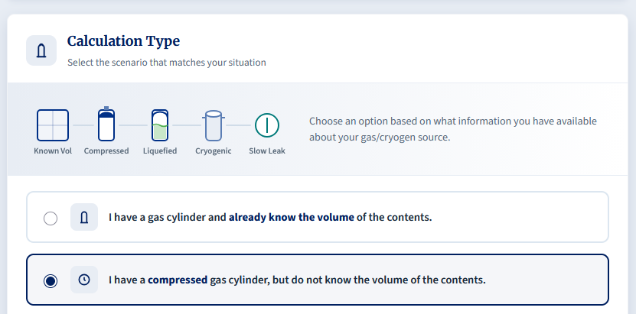
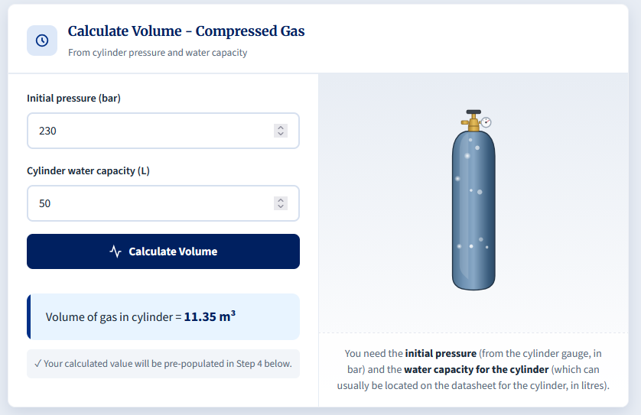
After clicking Calculate Volume, we are yielded a value of 11.35m³, and this corresponds to the volume of gas within the cylinder.
After this, we continue down the calculator, where we are asked for the Free Air Volume of the room. The volume of gas it automatically populated into the relevant field for us.
We input the free air volume and selected “Asphyxiant” as the gas hazard type.
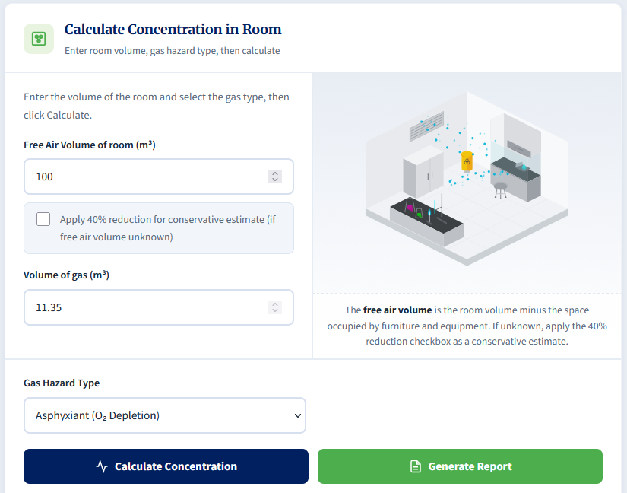
After this, the concentration of O₂ in the room is displayed in the event of a catastrophic release.
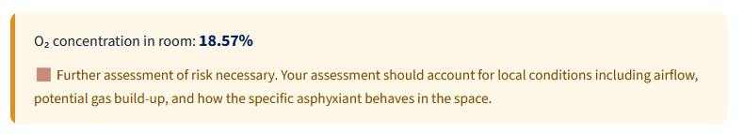
Similarly, a personal bubble calculation is automatically calculated as part of the process. This simulates the O₂ concentration in a 2x2x3 bubble which contains the cylinder.
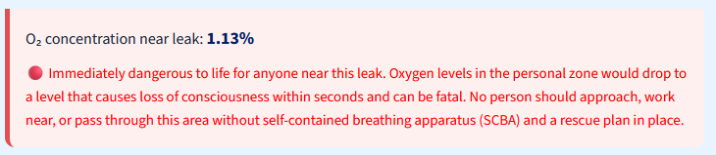

Scenario 2: Liquefied Gas (Toxic)
Answers:
- Gas Volume: 14m³.
- Room Concentration: 466,666.67ppm.
  - Methodology: The 40% reduction drops the 50m³ room to an effective free air volume of 30m³.
Explanation:
This scenario is asking us to determine the volume of gas that can be contained within a cylinder of liquefied gas. The phase of the medium is different, but we can still calculate the volume of gaseous contents that the cylinder contains.
This time, we select: “I have a liquefied gas cylinder, but do not know the volume of the contents.”
The scenario provides us with the weight of the cylinder contents (Exercise caution, as some supplier will include the weight of the cylinder PLUS the gaseous contents – we just want the weight of the contents) as well as the specific volume of the gas. Specific volume will be specific to the gas itself and can be located by searching online. Engineering Toolbox is a good site to visit to find these, but not all can be found there.
We simply enter both the weight of contents and specific volume and click “Calculate Volume”.
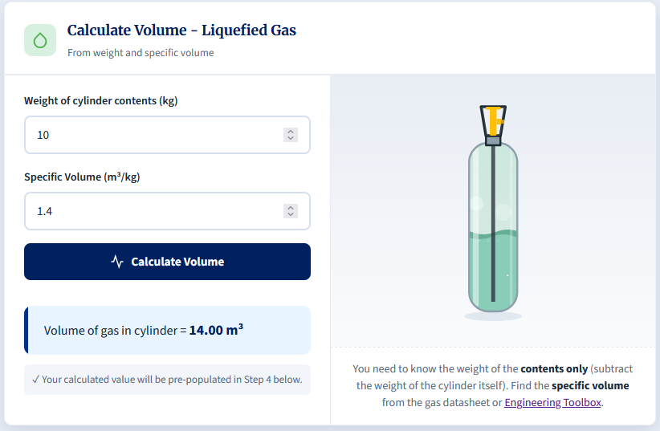
This calculation yields a volume of 14m³.
As before, we scroll further down to calculate the final room concentration of the gas during a catastrophic release.
The room volume is 50m³, but we don’t know how full of furniture it is, so we will apply the 40% volume reduction to estimate the free air volume. Note: This is a conservative estimate, but if your room/lab is significantly cluttered then it would be valuable to look to measure the free air volume by subtracting the volume of all equipment from the volume of the room.
In this instance, we select “Toxic” as the gas hazard type and click calculate.
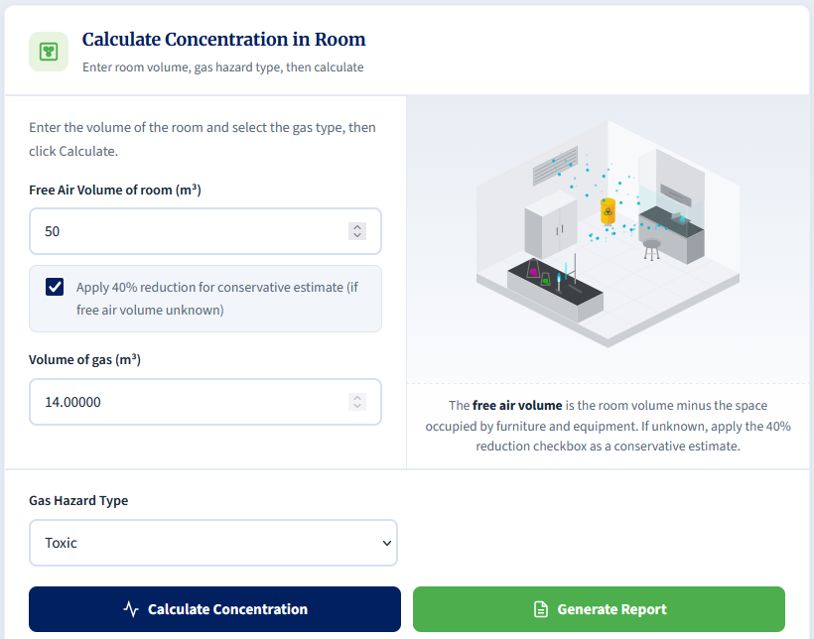
For toxic gases, a recommendation cannot be made from the number calculated itself. The workplace exposure limits (WELs) for these gases vary widely, and you will need to ensure you find the WEL for the gas you are using and compare it to the concentration calculated.
In this instance, a room concentration of 466,667 ppm is calculated which is likely to heavily exceed the most common WELs, and therefore controls would be needed to mitigate the risks to users in the area where the cylinder is contained.
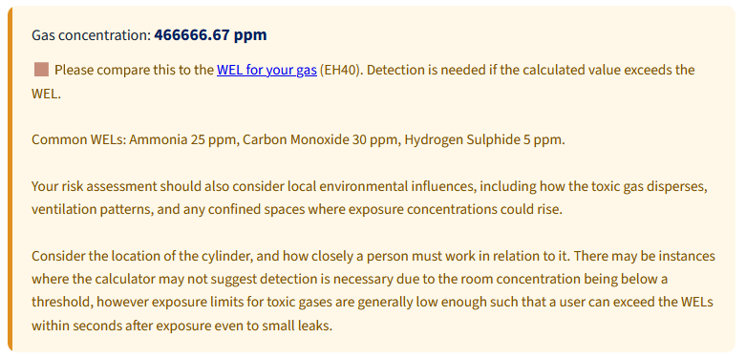

Scenario 3: Cryogenic Vessel (Asphyxiant)
Answers:
- Gas Volume Generated: 17.35m³.
  - Methodology: Liquid Nitrogen (LN₂) expands dramatically, multiplying by an expansion ratio of approximately 694.
- Room O₂ Concentration & Recommendation: 18.53%.
  - Recommendation: The calculator categorises levels between 18% and 19.5% as requiring further risk assessment, noting to account for local conditions, airflow, and gas build-up.
Explanation:
When cryogenic liquids heat up, they rapidly expand as they boil, creating hundreds of times the volumes of the initial liquid. This can lead to rapid creation of asphyxiation risks.
We begin by calculating the volume of the gas after expansion by selecting the option: “I have a Cryogenic vessel (Dewar / Tank).”
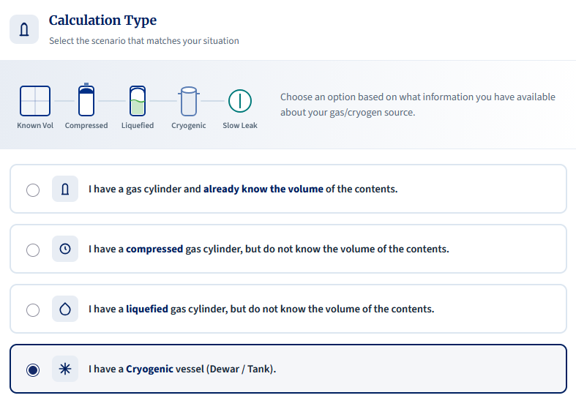
Following this, we need to select the cryogen we are using, as well as the known contents of the vessel. If in doubt, use the highest supported capacity of the vessel.
In this instance, we know it holds 25L of liquid nitrogen (LN₂), so we enter that into the calculator and click “Calculate Volume”.
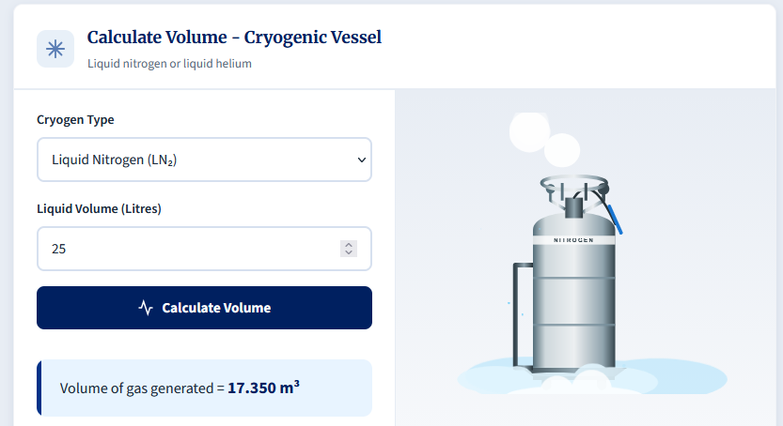
We can therefore determine that this dewar could release up to 17.35 m³ of nitrogen gas.
Scrolling down, we can then calculate the room concentration as we know the free air volume. We input that into the calculator, (the volume will be automatically input) and click “Calculate Concentration”.
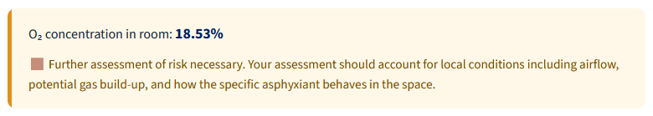
The calculator indicates further assessment of risk is necessary.
The likelihood is that with ventilation in the room, the O₂ concentration is not likely to dip into a hazardous region, but there could still be potential for localised effects to asphyxiate users should they work close to the source of the leak.
In instances like these, you should consider the hierarchy of control to ensure that the risk is eliminated/substituted as far as possible, either through use of smaller dewars (assuming the LN₂ is vital for the task), and checking that ventilation is sufficient to mitigate the residual risks. Detection is always a useful consideration to make users wary of leaks, but the need for this would be subject to risk assessment e.g. looking at whether working patterns/locations and existing controls are good enough to prevent a foreseeable event of asphyxiation.
Separately from the gas risk, the assessment must also consider effects of direct exposure to cryogenic liquids too.

Scenario 4: Known Volume (CO₂ Enrichment)
Answers:
- Room Concentration: 3.75%.
- Detection Required?: Yes.
  - Methodology: The calculator rules state that CO₂ detection is required if the concentration is above 0.5%.
Explanation:
In this example, we are provided with the volume of gas in the cylinder already. Some providers will provide this information up front, and it makes the calculation quite a bit easier to complete.
Knowing this, we can select the option: “I have a gas cylinder and already know the volume of the contents.”
From there, we simply enter the values from the scenario, selected Carbon Dioxide from the Gas Hazard Type dropdown, and click “Calculate Concentration”.
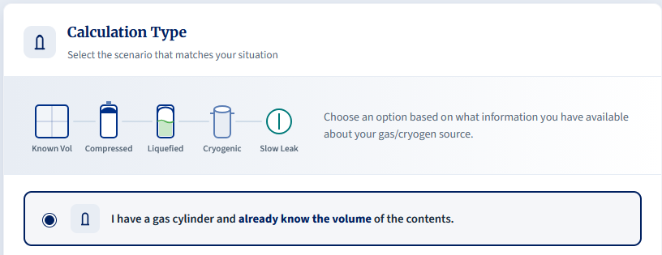
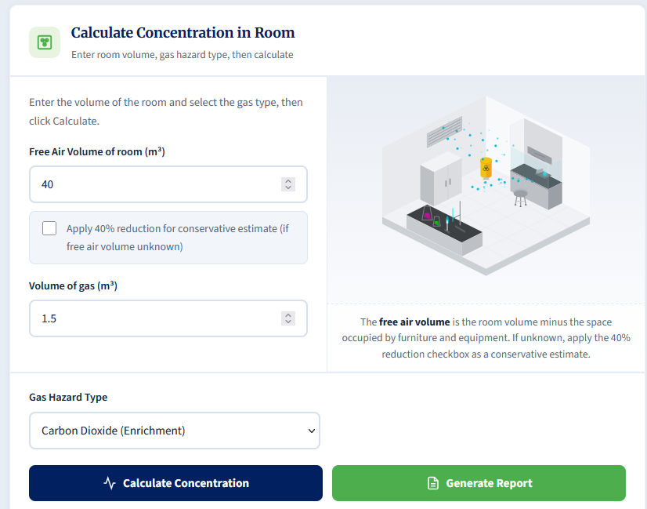
This yields a room concentration of 3.75% CO₂. As indicated below, the recommendation is such that detection must be considered as this level of gas release is well above the 0.5% limit.
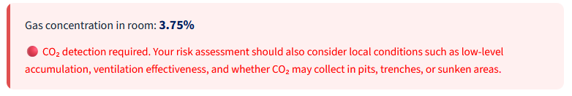

Scenario 5: Slow Leak (Flammable)
Answer:
- Steady-State Concentration: 0.21%.
Explanation:
Calculating the volume of a slow leak is not an exact science, and this calculator should be used with caution. If values are not known or measurable, then coming to an accurate conclusion on the risk to a person if difficult. You should avoid guessing leak rates and air changes and should prefer to measure where possible.
In this scenario, the leak rate is measured as 1 m³/hr. We begin by selecting the slow leak calculator:
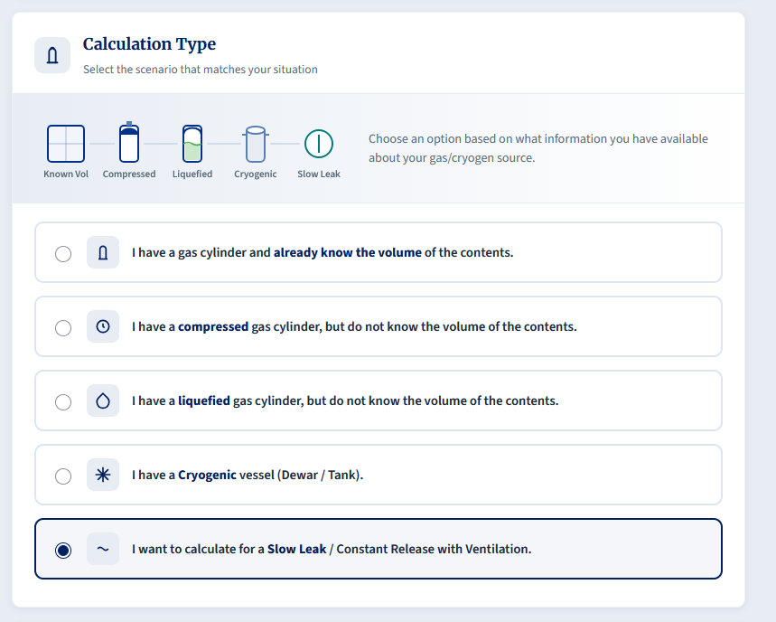
After this, we can enter all the details into the calculator. We enter the measured leak rate of 1 m³/hr, alongside the air changes of 6 and the free air volume of 80 m³. We then select Flammable as the Gas Hazard Type and click Calculate.
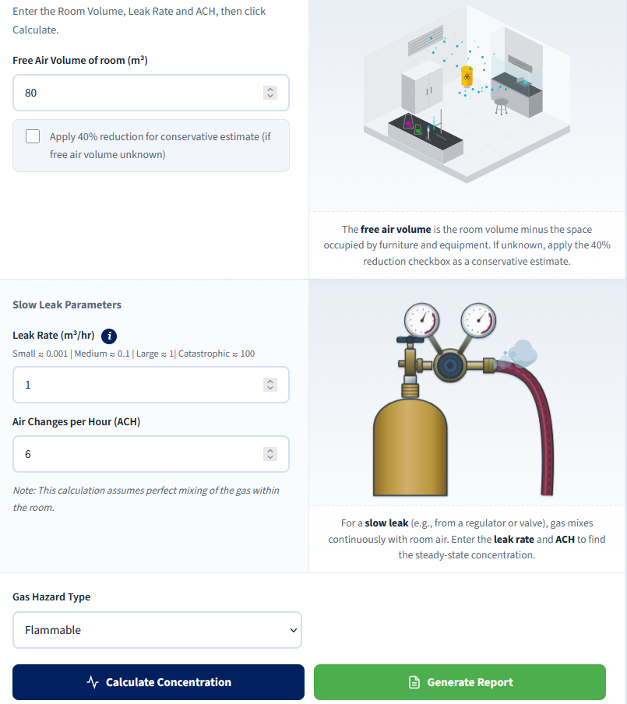
We end with a steady-state concentration of 0.21%. This is below 25% of the value of LELs for common flammable gases such as hydrogen and methane. The need for detection remains dependent on the specific gas, its LEL, local accumulation, ignition sources, and the proximity of work.
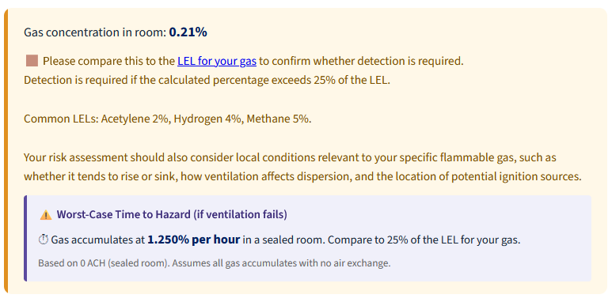

Scenario 6: Toxic Gas, External Lookups & Detection Placement
Answer:
- Gas Volume: 0.5m³.
  - Methodology: A standard BOC size 'AV' cylinder has a water capacity of 10 Litres, and an outlet pressure of 51 bar.
- Room Concentration: 6250 ppm.
- WEL & Detection Requirement: Yes, detection is required. The internal guidance notes a common WEL for CO is 20 ppm.
- Detector Type & Placement: Electrochemical sensor, mounted at breathing zone height (approx. 1.5m - 1.8m).
  - Methodology: Toxic gases require electrochemical sensors. CO has a density similar to air, so it is mounted at typical breathing height.
Explanation:
When calculating risks from compressed gas or cryogen hazards, we will likely need to search for the relevant data in order to carry out calculations. Different providers will provide different information which can make the process harder.
In this instance, we know the gas is Carbon Monoxide and the cylinder is an AV cylinder from BOC. We will need to visit their website to locate the details for the cylinder.
In this instance, the site lists 500L as the capacity for an AV cylinder, which corresponds to 0.5m³ of gas.
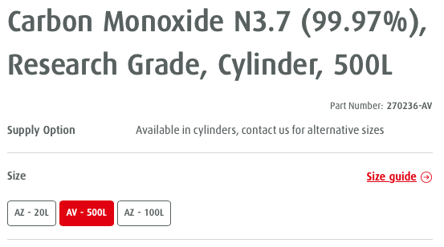
As we already know the gas volume (500L = 0.5m³), we can skip that calculation and go straight to “I have a gas cylinder and already know the volume of the contents.”
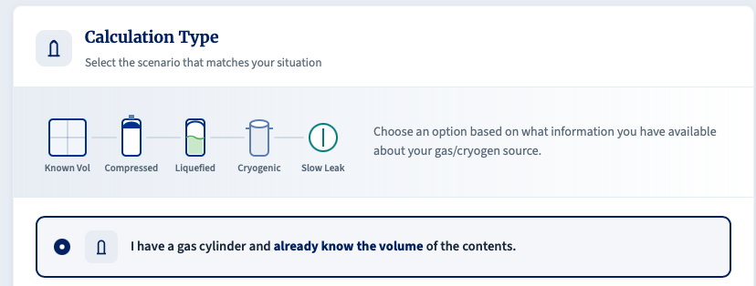
After selecting that, we enter the gas volume and free air space, as normal. We then select Toxic under the Gas Hazard Type and then Calculate Concentration.
By clicking calculate, we see that the room concentration will reach 6250 ppm if there is a catastrophic release.

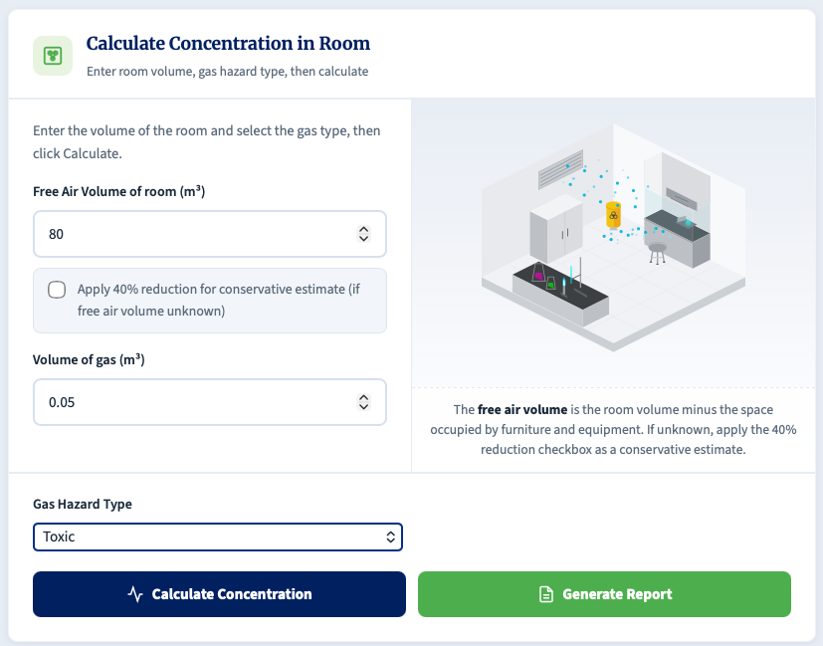
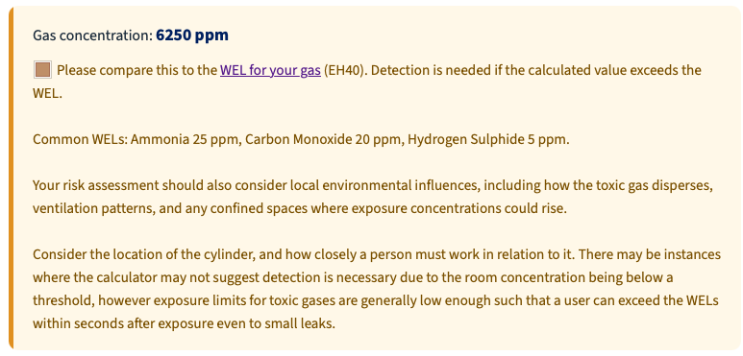
If we go to EH40 (linked in the calculation box within the calculator), we should check the applicable Carbon Monoxide exposure limits listed there. In practice, both the long-term and short-term exposure limits should be considered when interpreting the calculator output.
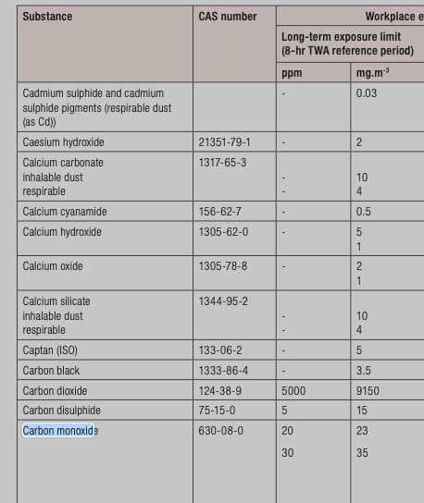
As a catastrophic release would be far above the relevant exposure limits, and because local concentrations near the source would also exceed the room average, detection and additional controls would be expected.
If we then click the “Generate Report” button in the calculator and scroll down, it can also provide recommendations for different types of detection as well as heights.
In this instance, the detector to be used would be an electrochemical sensor that would detect CO, and it would ideally be mounted in the breathing zone (between 1.5m – 1.8m) as the molecular weight of the gas is similar to that of air.
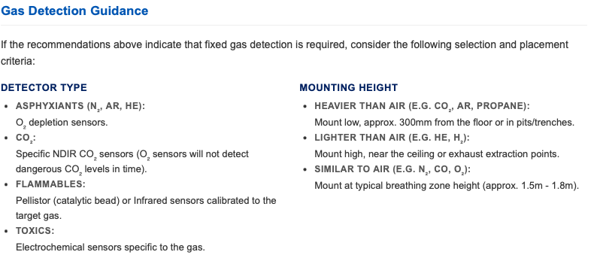

Scenario 7: Slow Leak, Time to Hazard & Heavy Gas Detection
Answer:
- Steady-State Concentration: 0.11%.
- Time to Hazard (to 0.5%): Approximately 2hrs 18 mins.
- Detector Type & Placement: If detection were required, the calculator guidance indicates that a specific NDIR CO₂ sensor mounted low (approx. 300 mm from the floor) would be appropriate.
  - Methodology: Standard O₂ depletion sensors do not replace a specific CO₂ sensor. CO₂ is heavier than air and tends to accumulate low.
Explanation:
As previously mentioned, calculating the volume of a slow leak is not an exact science, and this calculator should be used with caution. If values are not known or measurable, then coming to an accurate conclusion on the risk to a person if difficult. You should avoid guessing leak rates and air changes and should prefer to either measure, where possible, or rely on worst-case scenario calculations.
In this scenario, we know the gas, the size of the leak and the air changes we have (assuming all have been measured/confirmed).
Once again, we use the option for “I want to calculate for a Slow Leak / Constant Release with Ventilation.”
We can enter the free air volume but will need to calculate the leak rate. We can do this by selecting 'Estimate Leak Rate' and entering the regulator gauge pressure and equivalent hole diameter from the scenario.
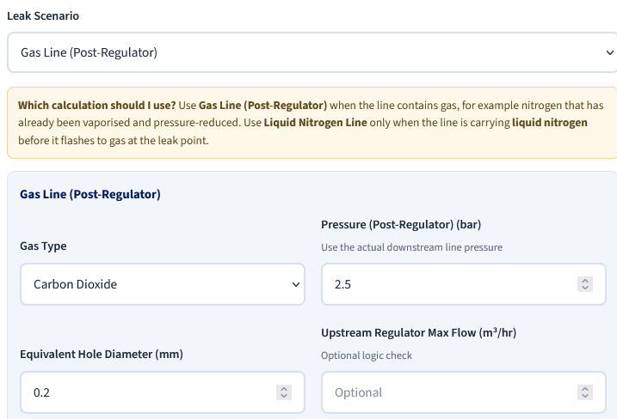
Note: We enter the regulator gauge pressure reading in bar(g), exactly as shown on the regulator, not a separately adjusted line pressure.
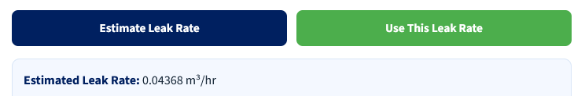
We then click Estimate Leak rate, which will be shown underneath the button. You can then click “Use this Leak Rate” to feed the value into the calculator.
We can then enter the Air Changes per Hour, selected Carbon Dioxide (Enrichment), and click Calculate Concentration.
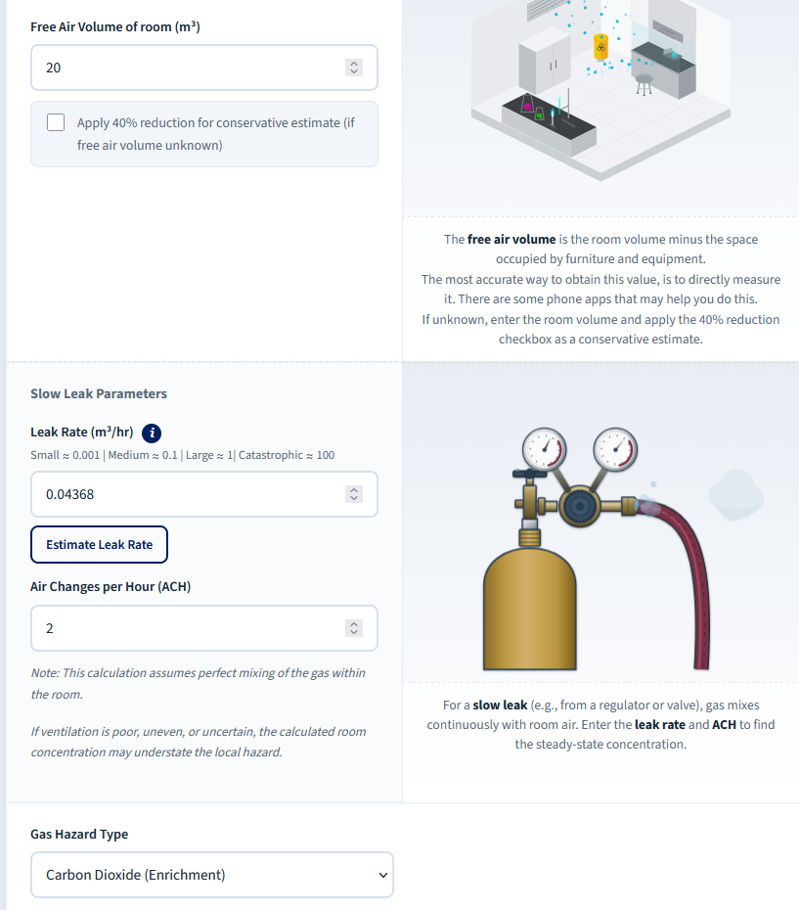
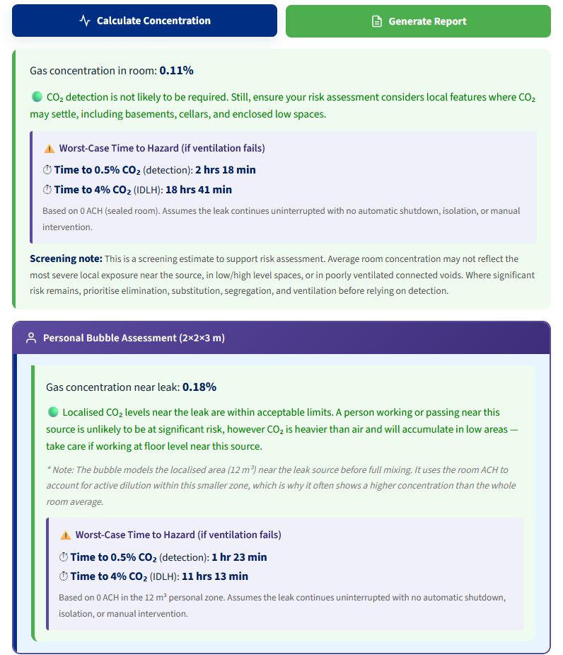
The steady-state concentration in the room is given as 0.11%, and therefore the room-average risk after gaseous equilibration is relatively low on this screening basis.
In the event of a full ventilation failure, the gas would build in the room as the potential for the air to be replaced is removed. In this instance, the calculator provides a 'Time to Hazard', and for the room it indicates that the time to reach the 0.5% CO₂ threshold is approximately 2 hrs 18 mins. This is a warning threshold for further action, not a claim that conditions remain acceptable up to that point.
If we review the generated report, it can also provide an indication of the detection type that might be necessary, although this calculation does not make detection a blanket recommendation. Where detection is required, the guidance indicates that an NDIR CO₂ sensor should be used and mounted low, at about 300mm above floor height.
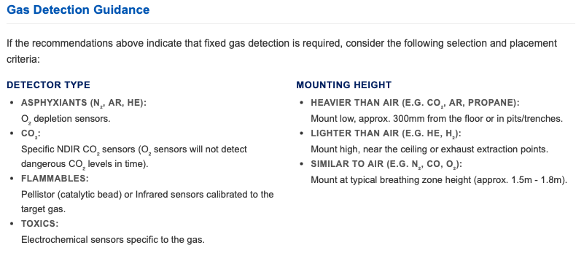

Scenario 8: Calculation Risk of Exposure when handling Dry Ice
Answer:
Maximum volume of CO₂ gas generated: 0.108m³
Local Risk Present?: The personal bubble assessment indicates a local concentration of 0.9%, so the calculator supports further assessment rather than a blanket conclusion that the task is low risk. The real significance depends on sublimation rate, duration, local airflow, and the worker's breathing-zone position relative to the dry ice.
Explanation:
For this calculation, we will look to use the Dry ice calculator, which can be accessed by clicking the “I have dry ice (solid CO₂) and want gas volume from a known mass.” button.
We know that we have 200g of Dry ice, which is 0.2kg – we enter that into the field and click Calculate Volume. This returns a gas volume of 0.108m³.
We can then continue down to calculate the concentration of the gas upon equilibration within the room, as well as obtain the personal bubble assessment.
We have the free air volume, and so can enter that into the field. The volume of gas will be pre-populated, and the Gas Hazard type will be pre-selected.
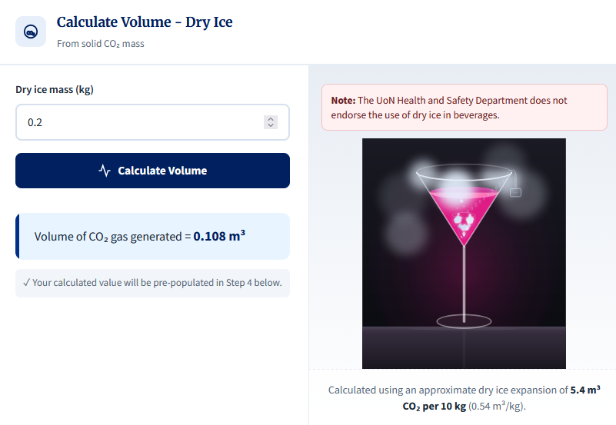
Click Calculate Concentration to obtain both the room and personal bubble concentration. In this scenario, we are only interested in the latter which comes out as 0.9%.
Note: The calculator attempts to provide generalised ideas of the level of risk to the user, and the activity must be taken into account and thought about closely. Where the personal bubble assumes a 2x2x3m zone around a leak/exposure, if a user is handling dry ice 50cm away from their breathing zone, the risk to them is quite different. Also, we need to take into account the fact that the gas created from sublimation is not likely to rise because of its density compared to air.
This calculation is for instantaneous release and calculates a worst-case scenario. Given the limit of 0.5%, we would appear to be above this so this calculation would determine that a further assessment of risk is necessary. For this, we need to expand our analysis to include the factors mentioned above.
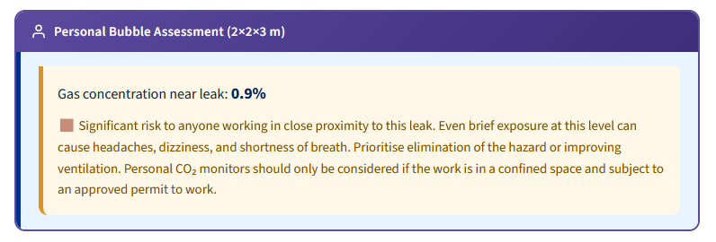
Assuming normal airflow in the lab and recognising that the gas will sink and will not all sublimate instantaneously, this example should still be treated as requiring judgement rather than proving the task is low risk. The fair conclusion is that the scenario does not obviously indicate a severe room-scale hazard, but local handling conditions still need to be assessed.
If the mass of dry ice being handled was much higher, it may be prudent to consider calculating the sublimation rate of the dry ice to determine the potential exposure, but calculations can become complicated quite quickly.

Scenario 9: Mixed Gas Cylinders & Multiple Independent Risks
Answer:
Gas Volume: 9.67m³. (Using the supplier volume for the cylinder contents.)
CO₂ Hazard: The CO₂ gas volume is 0.967m³ (10% of total). This results in a room CO₂ concentration of 3.22%, which is well above the calculator's 0.5% CO₂ threshold.
Hydrogen Hazard: The H₂ gas volume is 0.967m³ (10% of total). This results in a room H₂ concentration of 3.22%, which is above 25% of the LEL for hydrogen (1%).
Oxygen Depletion: The total gas release (9.67m³) displaces air, resulting in a room O₂ concentration of approximately 14.20%.
Detector Strategy: All three hazards are significant, but they do not reach their respective thresholds at the same point. On a room-average basis, the CO₂ threshold is reached first, followed by oxygen depletion, and then the hydrogen 25% LEL threshold.
Recommendation: On a room-average screening basis, a CO₂ detector is likely to provide the earliest alarm. That does not make oxygen depletion or hydrogen-related controls automatically redundant; the final detector strategy should be confirmed from the actual release scenario, room layout, ventilation pattern, and work location.
Explanation:
For calculations with mixed gases, knowledge of the hazards is required as this will allow you to determine which calculations need to be run.
For this scenario, we have a cylinder that contains 50L of gas, and that mixture comprises 10% CO₂, 10% H₂ and 80% N₂. CO₂ is primarily toxic before it is an asphyxiant, H₂ is flammable and can cause asphyxiation, and N₂ is an asphyxiant, so we have a variety of hazards to consider.
We start off by calculating the volume of the cylinder. We can go to the supplier website and find that the L sized cylinder for this gas mix contains 9.67m³ of gas.
We can calculate individual gas volumes by referring to the fractions of each gas in the cylinder. N₂ is 80% of the mixture and therefore accounts for 7.74m³ of gas, while CO₂ and H₂ are both 10% each and therefore account for 0.967m³ each.
In theory, as each of the gases is an asphyxiant, we can calculate the oxygen depletion risk using the full volume of the cylinder. We know everything we need to know already, and therefore we can use the “I have a gas cylinder and already know the volume of the contents.” option.
We populate the fields and ensure we are calculating the asphyxiation risk.
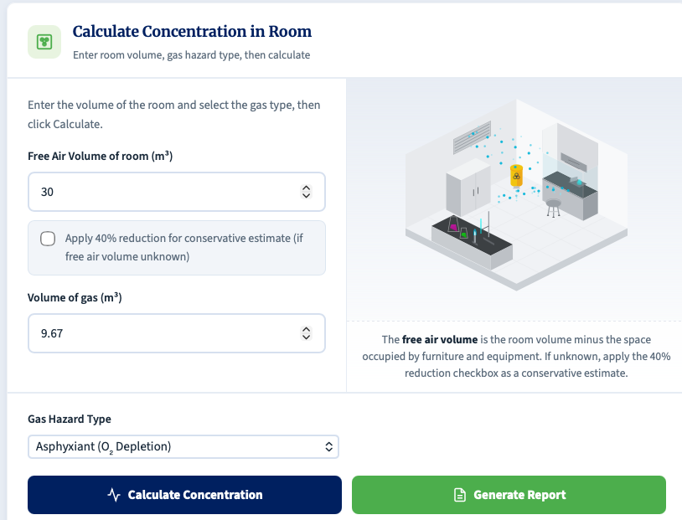
This yields a value of 14.2% O₂ concentration, indicating that the environment created has a risk of asphyxiation.
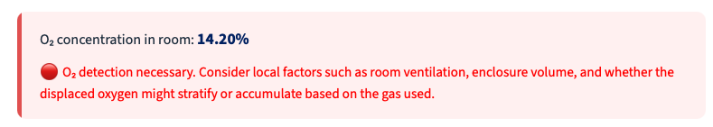
Continuing, we look at the CO₂ enrichment risk:
We do the same calculation again, but this time we use the CO₂ volume deduced above (0.967m³), and we select the Carbon Dioxide option, then calculate.
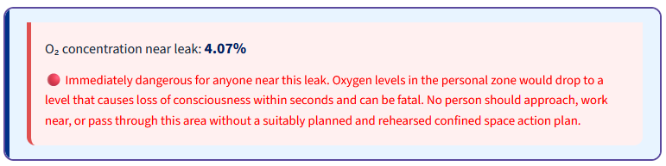
Similarly, this indicates we have the potential to create a hazardous environment in the event of a catastrophic release.
Lastly, we consider the H₂ risk. H₂ is a highly flammable substance, so we perform the same calculation once more using a volume of 0.967m³, but we select Flammable as the Gas Hazard Type.
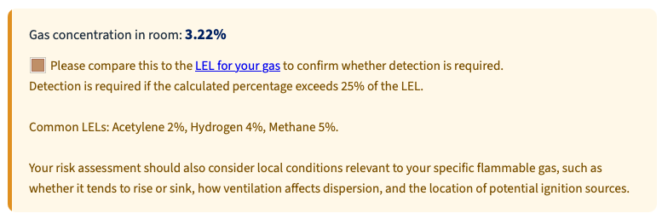
In this instance, we are at 3.22%, which exceeds 25% of the LEL for H₂ (1%).
As we can see, all three identified hazards have the potential to create a safety risk, but for different reasons.
In practice, a mixed-gas release should not be thought of as each component immediately behaving in isolation. The escaped gas will initially behave as a plume, and its movement will depend mainly on the overall properties of the released mixture, the release momentum, ventilation, and the room layout.
The calculator is therefore most useful for identifying which hazard threshold is reached first on a screening basis. That helps indicate which detector may provide the earliest warning, but it does not by itself prove that one detector is always sufficient or that other hazards can be ignored.
In this example, the CO₂ threshold is reached first on a room-average basis, so a CO₂ detector may provide the earliest general alarm. However, the final detector strategy should still be confirmed from the actual release scenario, plume behaviour, ventilation pattern, and work location – a recommendation from a competent gas detection installer is always preferred to relying solely on this calculator.

Part 3: Gas/Cryogen Safety Calculator: Mathematical Models
This document outlines the theoretical models and formulas utilised by the Gas/Cryogen Safety Calculator, based on the methodology detailed in example questions.

1. Volume Calculations
Before any concentration can be determined, the total volume of gas (measured at standard atmospheric pressure and temperature) must be calculated from the initial source parameters.
1.1 Compressed Gas Volume
This calculation is approximated using Boyle's Law (P₁V₁ = P₂V₂), assuming constant temperature, expanding the cylinder's internal capacity to standard atmospheric pressure.
$$V_{gas}=\frac{P_{cyl}×\left(\frac{V_{water}}{1000}\right)}{1.013}$$
Where:
V_{gas} = Total expanded volume of the gas (m³)
P_{cyl} = Initial pressure of the cylinder (bar)
V_{water} = Water capacity of the cylinder (Litres)
1000 = Conversion factor (Litres to m³)
1.013 = Standard atmospheric pressure (bar)
1.2 Liquefied Gas Volume
A direct mass-to-volume conversion using the specific volume of the gas at standard conditions.
$$V_{gas}=W×SV$$
Where:
V_{gas} = Total expanded volume of the gas (m³)
W = Weight of the liquefied contents (kg)
SV = Specific Volume of the specific gas (m³/kg)
1.3 Cryogenic Gas Volume
Utilises standard liquid-to-gas expansion ratios.
$$V_{gas}=\frac{V_{liquid}×E_{R}}{1000}$$
Where:
V_{gas} = Total expanded volume of the gas (m³)
V_{liquid} = Volume of the cryogenic liquid (Litres)
E_{R} = Expansion Ratio (e.g., 694 for Liquid Nitrogen, 757 for Liquid Helium)
1000 = Conversion factor (Litres to m³)

2. Room Concentration (Instantaneous Release)
This model assumes a catastrophic failure where the entire container contents are released immediately and mix perfectly into the room.
2.1 General / Flammable / CO₂ Concentration (%)
$$C_{\%}=\left(\frac{V_{gas}}{V_{room}}\right)×100$$
Where:
C% = Resulting concentration of the gas in the room (%)
V_{gas} = Total expanded volume of the gas (m³)
V_{room} = Free air volume of the room (m³)
2.2 Toxic Gas Concentration (ppm)
$$C_{ppm}=\left(\frac{V_{gas}}{V_{room}}\right)×1,000,000$$
Where:
C_{ppm} = Resulting concentration of the gas in the room (parts per million)
2.3 Oxygen Deficiency (Asphyxiant Concentration)
This calculation assumes that the gas released from the cylinder forces an equivalent volume of perfectly mixed 'normal air' out of the room. It assumes normal clean air contains exactly 20.95% oxygen by volume in an instantaneous release.
$$O_{2(\%)}=\left(\frac{\left(V_{room}-V_{gas}\right)×0.2095}{V_{room}}\right)×100$$
Where:
O_{2(%)} = Resulting oxygen concentration in the room (%)
0.2095 = Standard volume fraction of oxygen in normal air (20.95%)
2.4 Oxygen Enrichment
This calculates the concentration when pure oxygen is released into a room, accounting for the displacement of standard room air (assumed 21% baseline for this specific calculation).
$$O_{2\backslash \%}=\left(\frac{\left(V_{room}×0.21\right)+V_{gas}-\left(0.21×V_{gas}\right)}{V_{room}}\right)×100$$

3. Continuous Slow Leak (Steady-State)
This models a steady leak into a room with active ventilation. Based on a simplified steady-state mass balance equation, the room reaches 'steady state' when the rate of the hazardous gas entering exactly equals the rate of mixed air extracted.
3.1 Ventilation Rate (Q)
$$Q=V_{room}×ACH$$
Where:
Q = Volumetric flow rate of ventilation (m³/hr)
ACH = Air Changes Per Hour (hr⁻¹)
3.2 General / Flammable / CO₂ Concentration (%)
$$C_{\backslash \%}=\left(\frac{L}{Q}\right)×100$$
Where:
L = Leak Rate of the gas into the room (m³/hr)
3.3 Toxic Gas Concentration (ppm)
$$C_{ppm}=\left(\frac{L}{Q}\right)×1,000,000$$
3.4 Oxygen Deficiency (Asphyxiants)
Calculates the depressed equilibrium of oxygen levels (using a 20.9% baseline).
$$O_{2\%}=20.9×\left(1-\frac{L}{Q}\right)$$
3.5 Oxygen Enrichment
Calculates the elevated equilibrium of oxygen levels using a 20.9% air baseline and a steady-state mass-balance approach. In the current calculator, this reflects the additional oxygen above normal air rather than treating the incoming oxygen as a full 100% increase on top of the baseline.
$$O_{2\%}=20.9+\left(\frac{L}{Q}×100\right)$$

4. Worst-Case Time to Hazard (0 ACH)
This calculates the time required to reach a dangerous threshold if all building ventilation completely fails (0 ACH worst-case). It should be treated as a screening model with no ventilation removal, not as a literal sealed or pressurised box.

4.1 Oxygen Deficiency (Time to 19.5% and 18%)
Utilises a logarithmic decay function to find when the oxygen level drops to specific warning and danger thresholds.
Time to 19.5% (Warning Level):
$$t_{19.5}=\left(\frac{V_{room}}{L}\right)×\ln\left(\frac{20.9}{19.5}\right)$$
Time to 18.0% (Danger Level):
$$t_{18.0}=\left(\frac{V_{room}}{L}\right)×\ln\left(\frac{20.9}{18.0}\right)$$
Where:
t = Time required to reach the target concentration (hours)
ln = Natural logarithm
4.2 Gas Concentration (Time to 0.5% and 4% CO₂)
Utilises a logarithmic accumulation function for gases displacing room air.
Time to 0.5% (Detection/Warning):
$$t_{0.5}=-\left(\frac{V_{room}}{L}\right)×\ln\left(1-0.005\right)$$
Time to 4.0% (IDLH limit):
$$t_{4.0}=-\left(\frac{V_{room}}{L}\right)×\ln\left(1-0.04\right)$$
4.3 Oxygen Enrichment (Time to 23.5%)
Calculates the time until standard air is enriched to the critical 23.5% threshold.
$$t_{23.5}=-\left(\frac{V_{room}}{L}\right)×\ln\left(\frac{100-23.5}{100-20.9}\right)$$
4.4 Flammable / Toxic Linear Accumulation
Because standard exposure limits (LEL and WEL) vary drastically by specific gas, the calculator outputs a linear accumulation rate per hour for the user to compare against their specific gas limits.
Flammable Rate (% per hour):
$$Rate_{\%}=\left(\frac{L}{V_{room}}\right)×100$$
Toxic Rate (ppm per hour):
$$Rate_{ppm}=\left(\frac{L}{V_{room}}\right)×1,000,000$$

5. Dry Ice Conversion
The dry ice calculator converts solid CO₂ mass to equivalent gas volume using a fixed expansion factor of 0.54 m³/kg. This is intended as a practical approximation for the maximum gas volume generated by sublimation.
Where:
$$V_{gas}= m_{dry} × 0.54$$
m_{dry} ice = mass of dry ice (kg)

6. Advanced Leak-Rate Estimator
The advanced leak-rate estimator provides a rough leak-rate input for the Slow Leak calculation when a measured leak rate is not available. It is a screening method only and should not be treated as a detailed flow-calculation tool.
6.1 Gas Line (Post-Regulator)
For choked flow post-regulator gas leaks, the calculator estimates leak rate from regulator gauge pressure, equivalent hole diameter, and a gas factor. The gauge pressure is first converted internally to absolute pressure.
$$Q=0.4 × D^{2} × {(P}_{gauge}+1) × F_{g}$$
Where:
P_{gauge} = Regulator gauge pressure in bar(g)
D = Equivalent hole diameter (mm)
F_{g} = Gas-specific factor
This calculator uses an empirical approximation formula for quick field estimates. It assumes choked flow through a standard sharp-edged orifice at room temperature (~20°C). The baseline calculation is optimized for the thermodynamic properties of Air. When selecting other gases, the factor adjusts for molecular weight but does not correct for varying specific heat ratios, which may introduce an error margin of up to, approximately, 6% depending on the gas.
6.2 Liquid Nitrogen Line
For LN₂ line leaks, the calculator estimates the equivalent gaseous nitrogen hazard rate for oxygen-deficiency screening rather than the liquid flow rate itself.
Where:
$$Q_{{LN}_{2}, gas}=19.3×D^{2}× \sqrt{P_{gauge}}$$
P_{gauge} = Gauge pressure in bar
D = Equivalent hole diameter (mm)

6.3 Regulator Maximum Flow Cap
If an upstream regulator maximum flow is entered, the calculator applies a logic cap so that the leak rate used in the Slow Leak model cannot exceed the maximum flow the regulator can physically supply.

7. Recommendation and Threshold Logic
The calculator does not use a single generic risk rule for every gas. It applies different screening thresholds depending on the selected hazard type.
Asphyxiants: room oxygen below 19.5% prompts further assessment, and below 18% indicates a severe oxygen-deficiency risk.
Oxygen enrichment: oxygen above 23.5% indicates an enrichment risk requiring control.
CO₂: room concentration above 0.5% triggers the calculator CO₂ warning threshold, with higher local concentrations indicating more serious proximity risk.
Flammables: the calculator reports concentration and asks the user to compare it with the gas-specific LEL, including 25% of the LEL as a key screening threshold used in the current interface.
Toxics: the calculator reports ppm and requires comparison against the applicable occupational exposure limits for the specific gas.

8. Personal Bubble Assessment
A secondary calculation applied simultaneously to all scenarios to estimate the localised concentration immediately surrounding the leak.
It uses the exact same equations outlined in Sections 2, 3 and 4, but applies them to a smaller fixed zone.
The room volume (Vr_{oom}) is strictly replaced with 12m³ (representing an arbitrary 12 m³ workspace / 2 x 2 x 3 m zone).
Ventilation: For slow leaks, the ventilation rate (Q) becomes 12 x ACH.

